This is to certify that
(INSERT NAME HERE)
attended an online session of
Carpool Cases: Revision Masterclass -
Farm Animal
Hosted by
James Russell
on
Tuesday 10 May 2022
This equates to 1.5 hours of EMS*

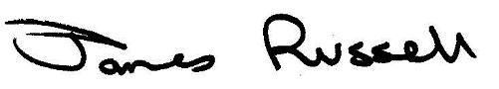
If your university requires it, this certificate is valid if screenshots are inserted into the boxes below. Note, please ensure any relevant information, such as the time, is visible.
SCREENSHOT TO SHOW BEGINNING OF SESSION
[Paste a screenshot of the beginning of the session, or recording, here]

SCREENSHOT TO SHOW END OF SESSION
[Paste a screenshot of the end of the session, or recording, here]

