This is to certify that
(INSERT NAME HERE)
attended an online session of
BVA Carpool Cases:
CV and interviews and looking forward

Presented by
Adrian Nelson Pratt
&
hosted by James Russell
on
Tuesday 23rd February 2021
This equates to 1 hour of EMS*
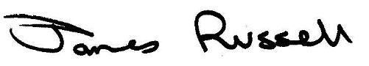
If your university requires it, this certificate is valid if screenshots are inserted into the boxes below. Note, please ensure any relevant information, such as the time, is visible.
SCREENSHOT TO SHOW BEGINNING OF SESSION
[Paste a screenshot of the beginning of the session, or recording, here]

SCREENSHOT TO SHOW END OF SESSION
[Paste a screenshot of the end of the session, or recording, here]

